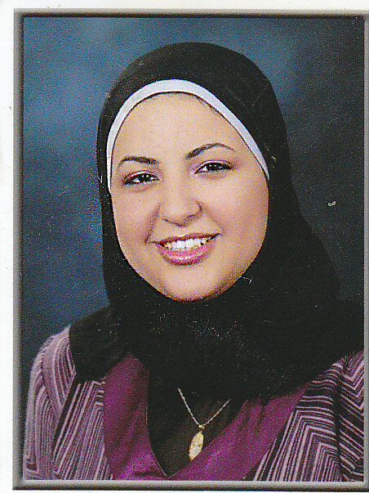 |  | Address :  Hadaba wosta beside modern academy , muqattam  cairo .egypt . | Mobile: 01009530952  E-mail : marwa_abdalaziz@yahoo.com
 | Marwa Abd AL-aziz Hassan

Objectives |  | In search of position of engineering graduate that will offer me excellent opportunity and challenge.
Personal Information  Education |  | - Marital status: married.  - Date of birth: 26th of March 1987.  - Age: 30 years.  - Driving license: Valid.
June 2009 B. SC. In Engineering and Technology
in Electrical Engineering Specialization
) Computer Engineering and Information Technology(
Modern Academy for Engineering and Technology
Good 66.31 %
July 2004 General secondary education certificate
Abraq-Khaitan School ,Kuwait.

Project |  | Real time tracking system based on GPS/GSM Technology  The Project Consist of :  - Sender (the vehicle)  - Receiver (which Tracking the vehicle).  Excellent.
Training Experience |  | - Completed the requirements studies of Electronic Courses  fundamental ( 30 Hrs). summer 2006.  - Attended Managing and maintaining a Microsoft Windows Server 2003 (70-290). summer 2007.  - Attended and complete the ORACLE SQL. summer 2008.
Work Experience  Languages |  | Worked at Egyptian language school 5th district as a computer teacher at 2012 till 2014  Arabic: Mother tongues.  English: Fluently Reading, Writing and Speaking.
Skills |  | - Computer skills: Well oriented with Office.  - Programming Languages: Q basic,visual basic , C++ , matlab.  - Communication skills.
Other irrelevant activities  Reference |  | Physical fitness (Gym), swimming.  To be furnished upon request.

